**East West University**

**Lab Report**

**Semester:** Summer-2024

**Course Title:** Electrical Circuits **Course Code:** CSE209

**Sec:** 01

**Expt No: 05**

**Expt Name: Measurement of node voltages using a voltmeter and mesh currents using an ammeter and comparison with theoretical results**

**Group No: 07**

**Submitted by-**

Name: Sheikh Sarafat Hossain

Id: 2022-3-60-109

**Submitted to-**

Dr. Sarwar Jahan

Associate Professor

Department of Computer Science & Engineering

East West University

**Date of Performance: 18-August-2024**

**Date of Submission: 25-August-2024**

**Name of the Experiment: Measurement of node voltages using a voltmeter and mesh currents using an ammeter and comparison with theoretical results**

**Objectives:** In this experiment, students will use a voltmeter to measure node voltages and an ammeter to measure the mesh currents. Finally, they will compare the measured results with the calculated results.

**Equipment and Components Needed:**

1. Power supply 0 - 30V DC

2. Resistors (50Ω×2, 100 Ω×2, 200Ω×2)

3. Wires

4. Ammeter

5. Voltmeter

6. Multimeter

**Circuit Diagram:**

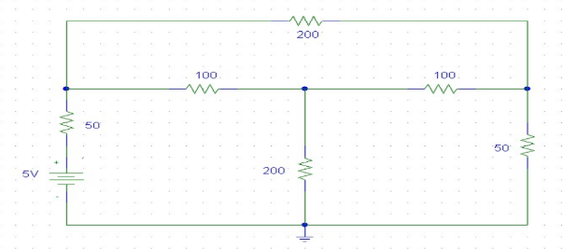

Figure 1

**Procedure:**

1. Connect the circuit as shown in Figure 1.

2. Measure the node voltages concerning the reference node using a voltmeter and record

those.

3. Verify the results with those of theoretical calculation using nodal analysis.

4. In the same circuit, measure the mesh currents using an ammeter.

5. Verify the results with theoretical calculation using the mesh current method.

**Data Sheet:**

**Experimental Calculation:**

|  |  |  |
| --- | --- | --- |
| **Resistance** | **Voltage** | **Current** |
| R1 = 57Ω | V1 = 3.47 V | I1 = 23mA |
| R2 = 118Ω | V2 = 1.8 V | I2 =10.2mA |
| R3 = 220 Ω | V3 = 0.95 V | I3 = 19mA |
| R4 = 226 Ω |  |  |
| R5 = 115 Ω |  |  |
| R6 = 56 Ω |  |  |

**Theoretical Calculation:**

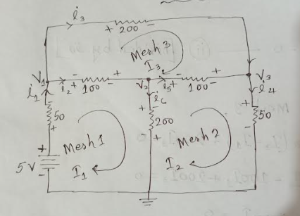

From Mesh Analysis,

Applying KVL in Mesh 1:

-5 + 50I1 + 100(I1 – I3) + 200(I1 – I2) = 0

50I1 + 100I1 – 100I2 + 200I1 – 200I2 = 5

350I1 – 200I2 – 100I3 = 5

70I1 – 40I2 – 20I3 = 1 ----------------- (1) [$∵Divided by 5$]

Applying KVL in Mesh 2:

50I2 + 100(I2 – I3) + 200(I2 – I1) = 0

50I2 + 100I2 – 100I3 + 200I2 – 200I1 = 0

-200I1 + 350I2 – 100I3 = 0

-4I1 + 7I2 – 2I3 = 0 ----------------- (2) [$∵Divided by 50$]

Applying KVL in Mesh 3:

200I3 + 100(I3 – I2) + 100(I3 – I1) = 0

200I3 + 100I3 – 100I2 + 100I3 – 100I1 = 0

-100I1 – 100I2 + 400I3 = 0

-I1 – I2 + 4I3 = 0 ----------------- (3) [$∵Divided by 100$]

Using Cramer’s rule:

$\left[\begin{matrix}70 & -40 & -20 \\ -4 & 7 & -2 \\ -1 & -1 & 4\end{matrix}\right]\left[\begin{matrix}I1 \\ I2 \\ I3\end{matrix}\right]$ = $\left[\begin{matrix}1 \\ 0 \\ 0\end{matrix}\right]$

$∴$ Δ = $\left[\begin{matrix}70 & -40 & -20 \\ -4 & 7 & -2 \\ -1 & -1 & 4\end{matrix}\right]$

= 70(28 – 2) + 40( -16 – 2) – 20(4 + 7)

= 880

$∴$ Δ 1 = $\left[\begin{matrix}1 & -40 & -20 \\ 0 & 7 & -2 \\ 0 & -1 & 4\end{matrix}\right]$

= 1(28 – 2)

= 26

$∴$ Δ 2 = $\left[\begin{matrix}70 & 1 & -20 \\ -4 & 0 & -2 \\ -1 & 0 & 4\end{matrix}\right]$

= -1( - 16 +2)

= 14

$∴$ Δ 3 = $\left[\begin{matrix}70 & -40 & 1 \\ -4 & 7 & 0 \\ -1 & 1 & 0\end{matrix}\right]$

= 1(- 4 + 7)

= 3

$∴$ I1 = 29.5mA

$∴$ I2 = 15.9mA

$∴$ I3 = 3.409mA

From Node Analysis,

i1 = 5 – V1 / 50

i2 = V1 – V2 /100

i3 = V1 – V3 /200

i4 = V3 /50

i5 = V2 – V3 /100

i6 = V2 /200

KCL in node V1:

i1 = i2 + i3

=>5 – V1 / 50 = V1 – V2 /100 + V1 – V3 /200

=>7V1 – 2V2 + V3 = 20 ----------------- (1)

KCL in node V2:

i2 = i5 + i6

=> V1 – V2 /100 = V2 – V3 /100 + V2 /200

=>2V1 – 5V2 – 2V3 = 0 ----------------- (2)

KCL in node V3:

i4 = i3 + i5

=> V3 /50 = V1 – V3 /200 + V2 – V3 /100

=>V1 + 2V2 – 7V3 = 0 ----------------- (3)

Using Cramer’s rule:

$\left[\begin{matrix}7 & -2 & 1 \\ 2 & -5 & -2 \\ 1 & 2 & -7\end{matrix}\right]\left[\begin{matrix}V1 \\ V2 \\ V3\end{matrix}\right]$ = $\left[\begin{matrix}20 \\ 0 \\ 0\end{matrix}\right]$

$∴$ Δ = $\left[\begin{matrix}7 & -2 & 1 \\ 2 & -5 & -2 \\ 1 & 2 & -7\end{matrix}\right]$

= 7(35 +4) +2(-14 + 2) +1(4 + 5)

= 258

$∴$ Δ 1 = $\left[\begin{matrix}20 & -2 & 1 \\ 0 & -5 & -2 \\ 0 & 2 & -7\end{matrix}\right]$

= 20(35 + 4)

= 780

$∴$ Δ 2 = $\left[\begin{matrix}7 & 20 & 1 \\ 2 & 0 & -2 \\ 1 & 0 & -7\end{matrix}\right]$

= -20(-14 + 2)

= -240

$∴$ Δ 3 = $\left[\begin{matrix}7 & -2 & 20 \\ 2 & -5 & 0 \\ 1 & 2 & 0\end{matrix}\right]$

= 20(4 + 5)

= 180

$∴$ V1 = 3.023 V

$∴$ V2 = -0.930 V

$∴$ V3 = 0.697 V

**Report:** After comparing the theoretical and measured values, we found some changes between the values. This change occurs by instruments.

**Discussion:**

